## LAB TASK 04

## TASK 1: Write a C program that takes a single character as input and check if the character is a vowel.

#include <stdio.h>

int main() {

char alphabet;

printf("Enter Single Character \n");

scanf("%c", &alphabet);

if (alphabet=='a' || alphabet=='e' || alphabet=='i' || alphabet=='o' || alphabet=='u') {

printf("%c is vowel", alphabet);

}

else if (alphabet=='A' || alphabet=='E' || alphabet=='I' || alphabet=='O' || alphabet=='U') {

printf("%c is vowel", alphabet);

}

else {

printf("%c is not a vowel", alphabet);

}

}

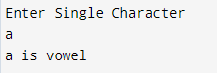 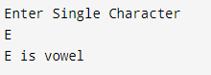

## TASK 2: Write a C program that describes the temperature as "Cold" (below 10°C), "Mild" (10-25°C), or "Hot" (above 25°C).

#include <stdio.h>

int main () {

int temperature;

printf("Enter your area temperatur in *Celcius \n");

scanf("%d", &temperature);

if (temperature < 10) {

printf("it's so COLD in your area'");

}

else if (temperature >= 10 && temperature <= 25) {

printf("it's MILD in your area'");

}

else if (temperature > 25) {

printf("it's so HOT in your area'");

}

else {

printf("invalid"); }}

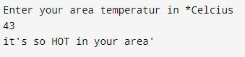

## TASK 3: Write a C program that checks if a student is eligible for a scholarship. The student must have a GPA of 3.5 or higher. If this condition is met, further check if the student has extracurricular activities, making them eligible.

#include <stdio.h>

int main () {

float GPA;

char activities;

printf("Enter your GPA \n");

scanf("%f", &GPA);

if (GPA >= 3.5) {

while ((getchar()) != '\n');

printf("Are you involve in extracurricular activities? (y/n) \n");

scanf("%c", &activities);

if (activities=='y' || activities=='Y') {

printf("You are eligible for scholarship.");

}

else {

printf("You are not eligible for any scholarship.");

}

}

else {

printf("You are not eligible for any scholarship.");

}

}

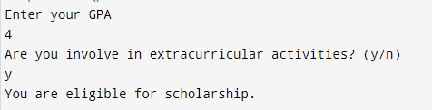

## TASK 4: Input two numbers and determine whether the numbers are equal or not, if numbers are not equal then determine which one is greater and which one is less.

#include <stdio.h>

int main() {

int x,y;

printf("Enter your first number: ");

scanf("%d", &x);

printf("Enter your second number: ");

scanf("%d", &y);

if (x == y) {

printf("Given numbers are equal to each other");

}

else {

printf("Given numbers are not equal to each other");

if (x > y) {

printf("\nfirst number is gretaer than second number");

}

else {

printf("\nsecond number is gretaer than first number");

}

}}

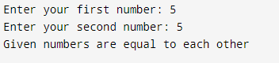

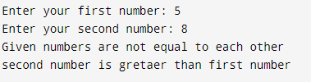

## ASK 5: Write a C program that takes two inputs: a character representing the vehicle type (C for Car, M for Motorcycle) and a number representing the specific model. Use a nested switch statement to display the model's details based on the vehicle type and model number.

#include <stdio.h>

int main() {

char type;

int model;

printf("Enter your vehicle type (c for car, m for motorcycle): \n");

scanf("%c", &type);

switch (type) {

case 'c':

case 'C':

printf("Enter your vehicle model (1 for Sedan, 2 for Hatchback, 3 for SUV): \n");

scanf("%d", &model);

switch (model) {

case 1:

printf("Model 1: Sedan, 1500cc, 4-door");

break;

case 2:

printf("Model 2: Hatchback, 1300cc, 5-door");

break;

case 3:

printf("Model 3: SUV, 2000cc, 4-door");

break;

default:

printf("Invalid model number");

}

break;

case 'm':

case 'M':

// Prompt for vehicle model

printf("Enter your vehicle model (1 for Cruiser, 2 for Sports, 3 for Dirt Bike): \n");

scanf("%d", &model);

switch (model) {

case 1:

printf("Model 1: Cruiser, 250cc");

break;

case 2:

printf("Model 2: Sports, 600cc");

break;

case 3:

printf("Model 3: Dirt Bike, 450cc");

break;

default:

printf("Invalid model number");

}

break;

default:

printf("Invalid vehicle type");

}

}

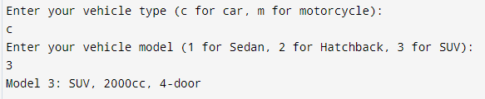

## TASK 6: The body mass index (BMI) is the ratio of the weight of a person to the square of the height. Write a program that takes two inputs, weight and height, computes the BMI, and prints the corresponding BMI category:

#include <stdio.h>

int main() {

float weight,height,BMI;

printf("Enter your weight\n");

scanf("%f", &weight);

printf("Enter your height in inches\n");

scanf("%f", &height);

BMI = (weight*703)/(height*height);

if (BMI < 15) {

printf("Starvation");

}

else if (BMI < 17.5) {

printf("Anorexic");

}

else if (BMI < 18.5) {

printf("Underweight");

}

else if (BMI >= 18.5 && BMI < 25) {

printf("Ideal");

}

else if (BMI >= 25 && BMI < 30) {

printf("Overweight");

}

else if (BMI >= 30 && BMI < 40) {

printf("Obese");

}

else if (BMI >= 40) {

printf("Morbidly Obese");

}

else {

printf("invalid");

}}

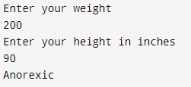

## TASK 7: Write a C program that calculates the shipping cost based on the shipping method chosen by the user. The user will input a letter representing the shipping method:

#include <stdio.h>

int main (){

int cost;

char shipping;

float totalCost;

printf("Enter shipping method \n E: Express (Rs. 200) \n S: Standard (Rs. 100) \n O: Overnight (Rs. 300) \n R: Regular (Rs. 50)\n");

scanf("%c", &shipping);

printf("Enter your Product cost \n");

scanf("%d", &cost);

switch (shipping) {

case 'e':

case 'E':

printf("Your total coast including shipping is %d", cost + 200);

break;

case 's':

case 'S':

printf("Your total coast including shipping is %d", cost + 100);

break;

case 'o':

case 'O':

printf("Your total coast including shipping is %d", cost + 300);

break;

case 'r':

case 'R':

printf("Your total coast including shipping is %d", cost + 50);

break;

default:

printf("invalid shipping ,method");

}

}

